**JAVA LAB FAT Prashanth.S(19MID0020)**

**Question**

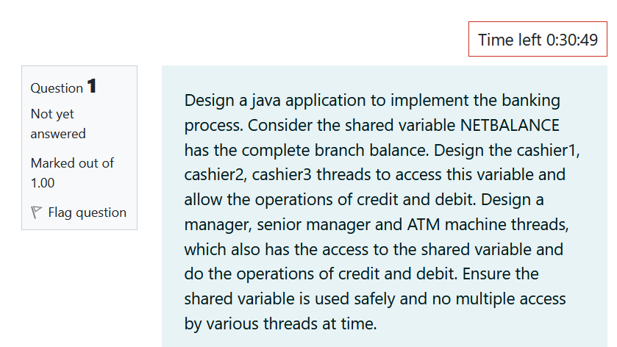

**Code screen shot**

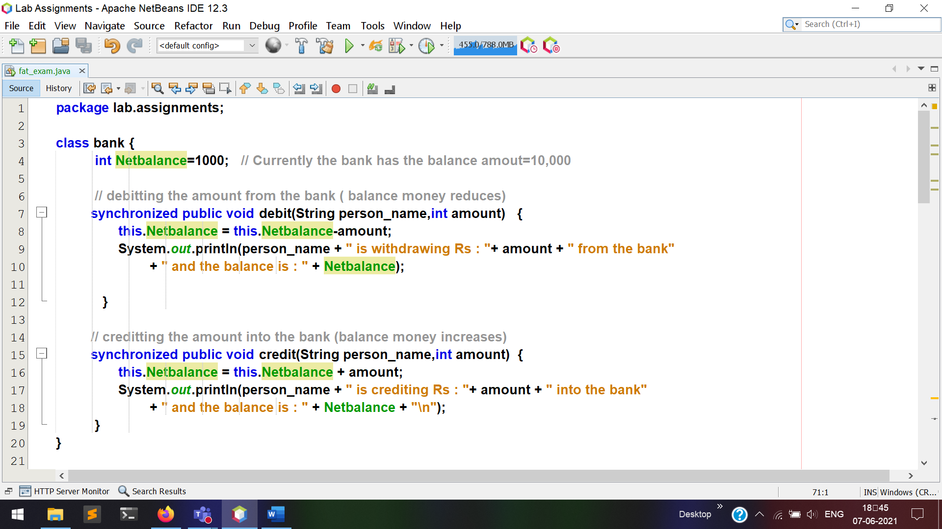

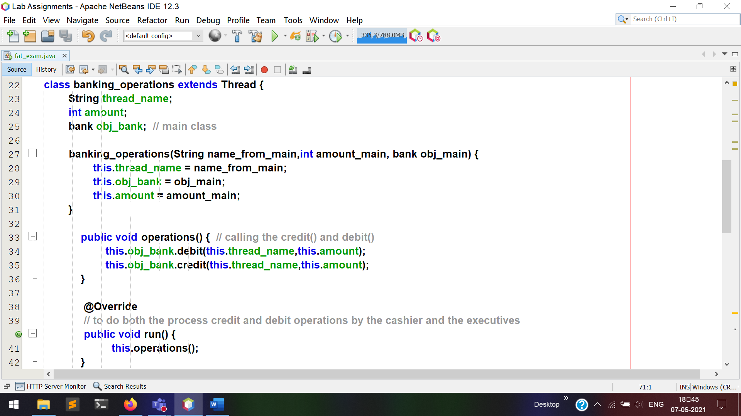

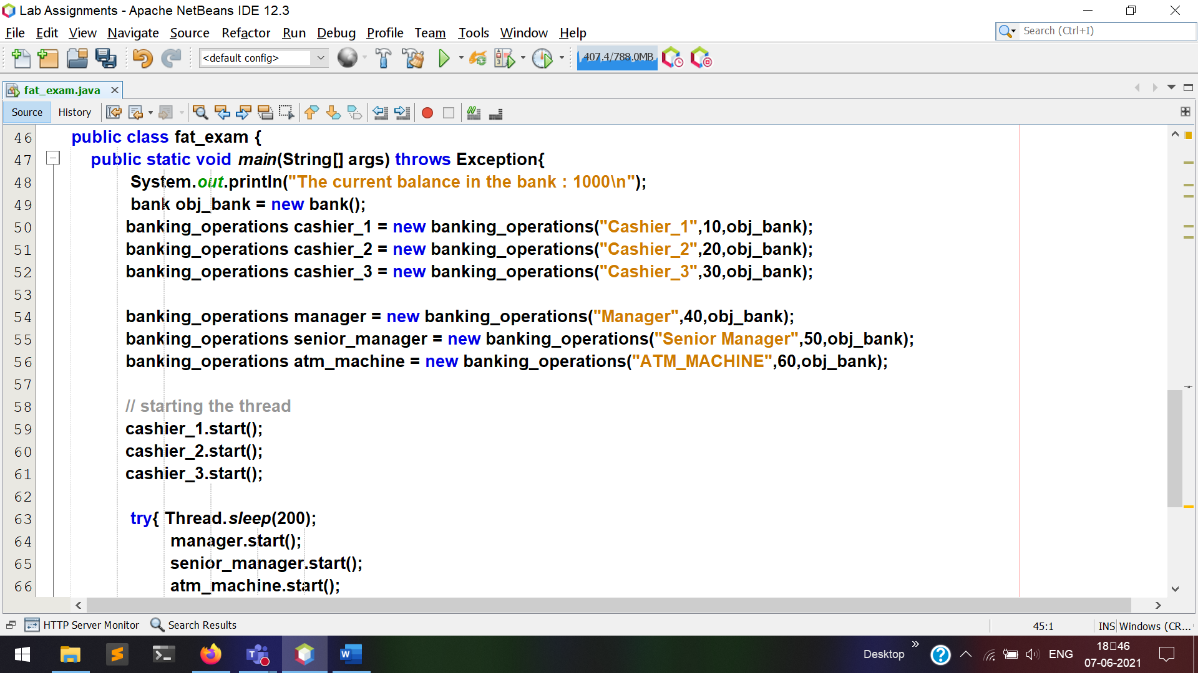  


**Output**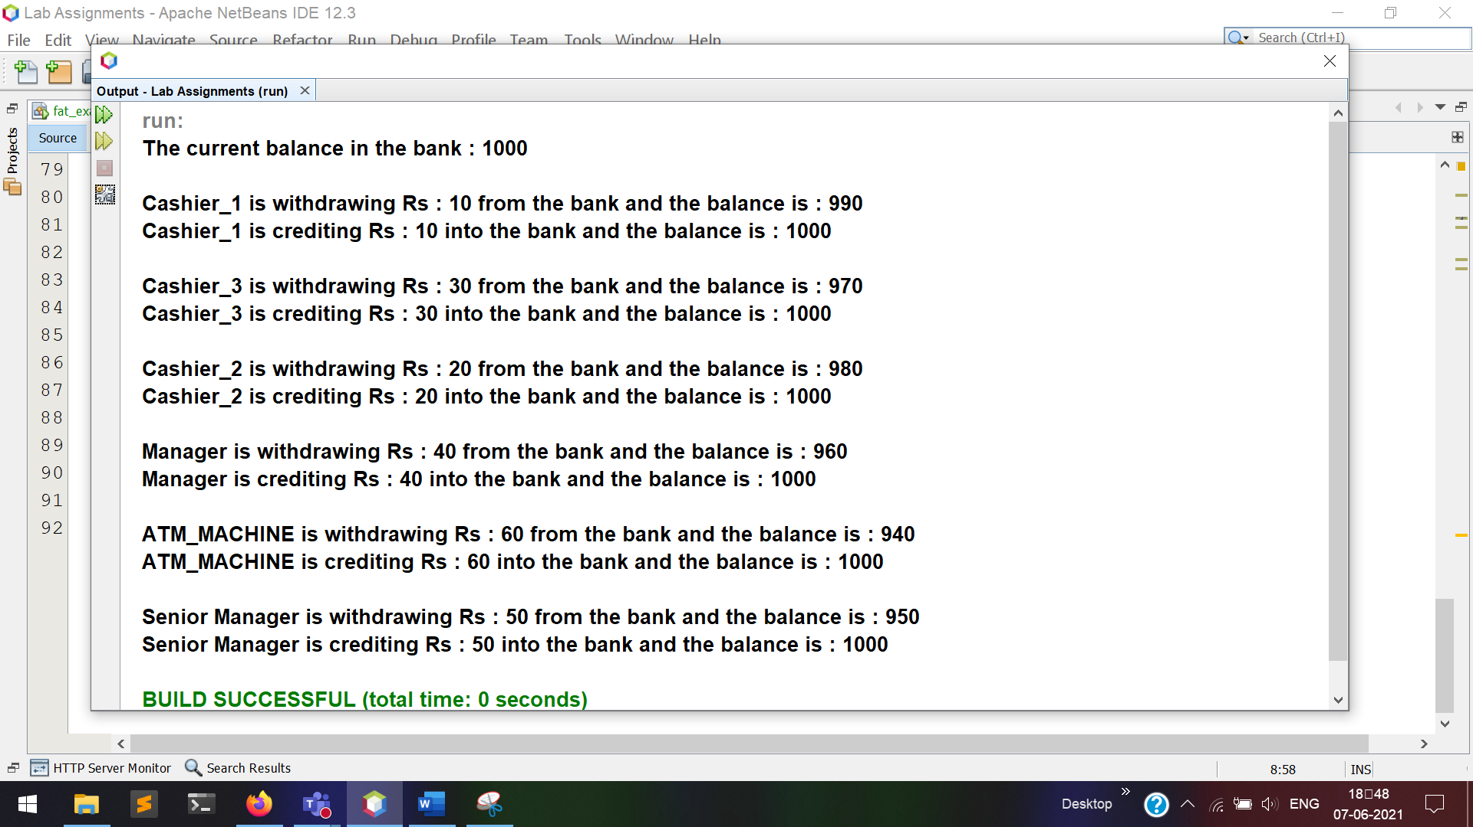

**Actual Code**

package lab.assignments;

class bank {

int Netbalance=1000; // Currently the bank has the balance amout=10,000

// debitting the amount from the bank ( balance money reduces)

synchronized public void debit(String person_name,int amount) {

this.Netbalance = this.Netbalance-amount;

System.out.println(person_name + " is withdrawing Rs : "+ amount + " from the bank"

+ " and the balance is : " + Netbalance);

}

// creditting the amount into the bank (balance money increases)

synchronized public void credit(String person_name,int amount) {

this.Netbalance = this.Netbalance + amount;

System.out.println(person_name + " is crediting Rs : "+ amount + " into the bank"

+ " and the balance is : " + Netbalance + "\n");

}

}

class banking_operations extends Thread {

String thread_name;

int amount;

bank obj_bank; // main class

banking_operations(String name_from_main,int amount_main, bank obj_main) {

this.thread_name = name_from_main;

this.obj_bank = obj_main;

this.amount = amount_main;

}

public void operations() { // calling the credit() and debit()

this.obj_bank.debit(this.thread_name,this.amount);

this.obj_bank.credit(this.thread_name,this.amount);

}

@Override

// to do both the process credit and debit operations by the cashier and the executives

public void run() {

this.operations();

}

}

public class fat_exam {

public static void main(String[] args) throws Exception{

System.out.println("The current balance in the bank : 1000\n");

bank obj_bank = new bank();

banking_operations cashier_1 = new banking_operations("Cashier_1",10,obj_bank);

banking_operations cashier_2 = new banking_operations("Cashier_2",20,obj_bank);

banking_operations cashier_3 = new banking_operations("Cashier_3",30,obj_bank);

banking_operations manager = new banking_operations("Manager",40,obj_bank);

banking_operations senior_manager = new banking_operations("Senior Manager",50,obj_bank);

banking_operations atm_machine = new banking_operations("ATM_MACHINE",60,obj_bank);

// starting the thread

cashier_1.start();

cashier_2.start();

cashier_3.start();

try{ Thread.sleep(200);

manager.start();

senior_manager.start();

atm_machine.start();

}catch(Exception e){};

}

}